Design it Clean: Group Document.
- Teddy: Researcher.
- Jason: Director/ Leader Caplin the Captain
- Sabina: The Collector
- Caity: The Organizer
- Skylar:The Designer

Completion that day
Jason | Constructed the water filter | tested water filter, worked on document | continued to work on the document | collaboration with other groups
Caity | /// | individual research of the algae in the water | more research on the water problems | collaboration with other groups
Sabina | /// | algae leaves in canada and is a problem for their water | started the drawing of our first model of our filter | collaborating with others
Teddy | Constructed water filter. Brought in parts. | Tested water filter.  Made second draft drawing. | I worked on the document on the physical geography. | Collaboration with other groups
Skylar | out of town from february 13 to the 20. | tested water filter organized what to work on document. | worked on document the bullet point on religion & culture. | collaboration with other groups.

Questions:
What was the cause for the water to turn cloudy? To many air bubbles but it is harmless.
What are the symptoms? Sever cramping and diarrhea.
What exactly was infecting the water and how can we find it and prevent it? E Coli and coliform.
How small is bacteria? 80 micrometers.

Research:
Canada has the largest water hord next to Brazil and Russia.
Sixty percent of Canada's water flows where we do not want it to go back into the ocean.
All of their water is infested with blue and green algae.
Many residents of Canada pull their water from lakes which usually is full of different kinds of bacteria. Blue green algae can grow all year long it has even been known to grow under the ice. Blue green algae tend to grow on the surface of the water which is known to most people as pond scum. It can grow in ponds lakes and very slow moving rivers and streams. Although it can not grow in aquifers so if it was not so expensive to drill them it would be a viable option.
One option that we found was the bios sand water filtration system. The way it works is the water passes through different layers of sand, dirt, and gravel. Then it comes out of the tube at the bottom as clean filtered water. This kind of water system has been proven to remove ninety percent of bacteria and one hundred percent of parasites. Our filter is a
http://dnr.wi.gov/lakes/bluegreenalgae/

The materials of the first filter:
Sand
large sand
small and large pebbles
fertilizer/soil
gravil
charcoal
small rocks
rubber tube used for the clean water to funnel through.
Two cups
Then it is suspended in the air with a harness.
Then you want to stick the tube in a clean container for the water to be stored.
We are going to make the way that the dirty water filters in like a dog water bowl. We will get a tall narrow bottle and fill it with water then you will place it in the filter. But because the lip of the bottle is underneath the edge of the cup it will not overflow.
Overall cost is approximately twenty dollars. The way that the layers are lined up is small to large to small to large. This process will stop all micro organisms from passing through.
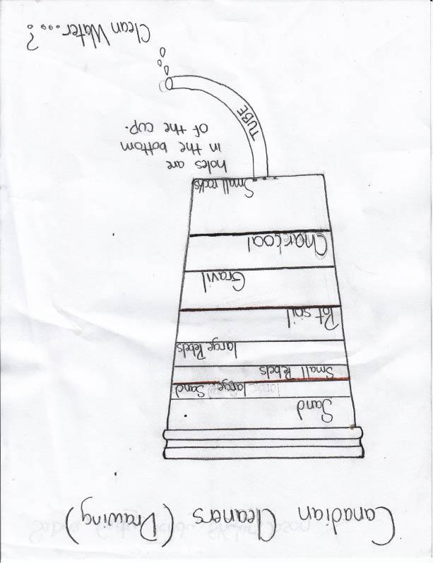First Draft.
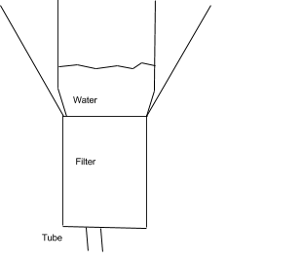

Sources:
http://dnr.wi.gov/lakes/bluegreenalgae/
http://thewaterproject.org/biosand_water_filtration
https://www.koshland-science-museum.org/water/html/en/Treatment/Filtration-Systems-technologies.html
http://www.cawst.org/en/resources/biosand-filter
http://www.ec.gc.ca/eau-water/
http://www.aquariumslife.com/saltwater-diy-projects/diy-algae-filter-screen/
http://www.et.byu.edu/~wanderto/homealgaeproject/Harvesting%20Algae.html
Second Draft:
When we did our first test it worked fine but when we tried it a second time it did not work because the top layer of fine sand had compacted into a solid piece. Because of this it was like one drop falling out every thirty seconds. It would not be very practical for someone to water five hours for one ship of water. So we completely changed the design using sponges activated carbon and cat litter.

The test:
Microorganisms test
When we tested the micro organisms water before it went in the filter we saw four micro organisms floating across side to side. And then after it was filtered there was nothing when we went side to side.
Turbidity test
When we did the turbidity test the initial clarity depth was six centimeters. But after the water was put through the filter it was all clear.
Ammonia test
Initial (ppm) 4.0
Final (ppm) .25
Nitrate test
Initial 5.0
Final 0
Second draft filter materials:
Sponge
Cat litter
activated carbon
One one liter bottle.

Filter design and second draft:

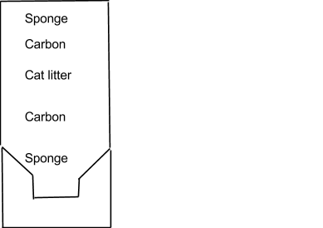

Area Description of Nova Scotia/Canadian Cleaners:
- Religion & Culture
Canada’s religion is mainly Christianity. Also 90% of the population has claimed adherence. In Nova Scotia there are over 3,000 lakes as well as many different streams. Also no shortage of water usually occurs. The rivers have significant history. Some of the rivers were used for early transportation. Overall most of their culture remains around agriculture and conserving the most important resources.
- Political System
While the responsibility for the provision of water supply and sanitation services in Canada lies with municipalities, the provincial governments and the federal government also have important responsibilities related to the setting of standards, research, economic regulation and water resources management. As all levels of government hold key policy and regulatory levers which apply to water and sanitation, a central challenge is to ensure that these levers are developed and used collaboratively. The Canadian council of municipal government, which consists of the 14 environment ministers from the federal, provincial and territorial governments, plays an important role in the development of national strategies, norms and guidelines for water supply and sanitation
- Physical Geography:
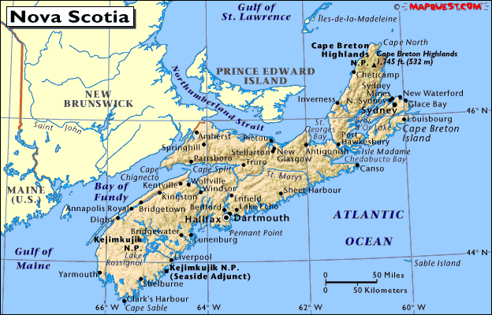
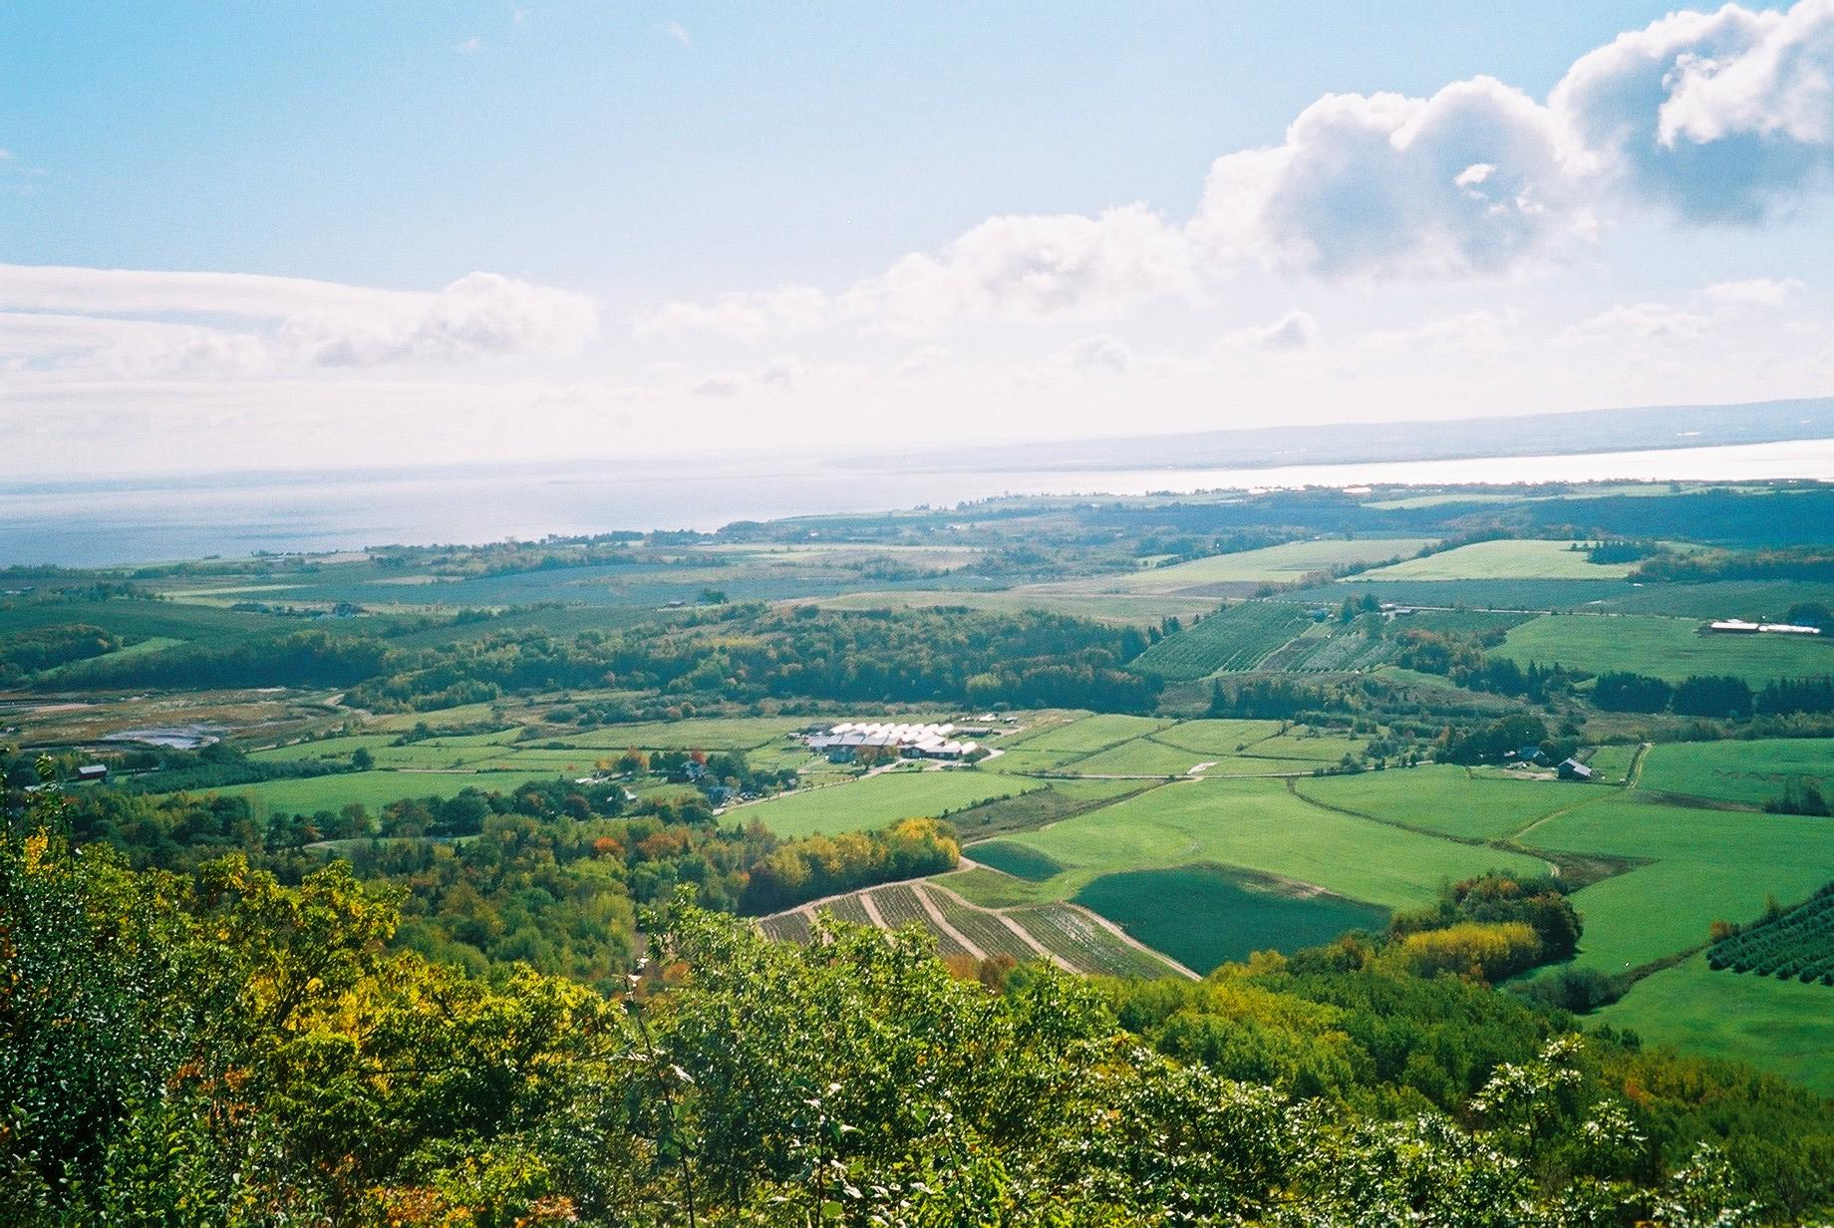
The country Canada has a very mostest climate and has lakes and rivers everywhere. There problem is not that they do not have enough water. It is that they do not have enough of it that is clean. Sixty percent of Canada's water flows off where we do not want it to go. In Quebec they have very large amounts of blue green algae. When they tried to pump the algae out the water levels plummeted. Forty percent of Montreal's water cargo if full of lead because of a pipe burst. The great lakes are also at a record low because of factories and housing all along it using up all the water. Farmers have barely been able to keep their farms going due to them being denied the amounts of water that is needed. Canada is second in the world for using the most water, first is the united states. The average Canadian uses 335 litres of water daly. Many Canadian and American Cities Dumps 90 billion liters of raw sewage into the great lake each year. The amount of fish population throughout canada have plummeted because of pollution and dams being made and water diversion. Nova Scotia has many farmers and livestock which cause overabundance of nutrients. Because of all of the nutrients in the water the growth rate of algae and other water growing organisms exploded. Large amounts of algae will float across the surface, (locally known as pond scum) and because of this it kills all other plant life leaving nothing but algae. The majority of Nova Scotia pulls water from lakes not from aquifers that are deep underground. Canada is completely surrounded by the ocean but seawater takes too much time and money to filter. One point one billion people that have water issues must survive on five liters a day. Canada has a little over two million lakes which covers seven percent of the country. Canada occupies an area of 9,970,610 square miles. Because of the harsh weather conditions up in northern Canada most of the population lives by the southern border. Canada has many mountain ranges stretching all across the country. The largest mountain in Canada is known as Mount Logan. Despite all of Canada's water problems there plant and tree life is flourishing. As well as their animal life, well besides the fish. Next to the united states Canada has the largest amount of lumber distribution throughout the world. Canada has large amounts of diamonds gold Oil gas and other base metals. The natural hazards that Canada Is faced with is earthquakes, landslides, forest fires, and floods. The most common kinds of rock in Canada are a rusty coloured sedimentary and volcanic strata, Ptarmigan Fiord.
http://www.canada.com/vancouversun/story.html?id=1d324e25-0a20-4e3e-b1ba-ea2f35386bb0
http://yourcanada.ca/geography/canadian-mountain-ranges/

http://www.nrcan.gc.ca/forests/industry/13305

www.parl.gc.ca/about/parliament/.../touchpoints_content-e.html

